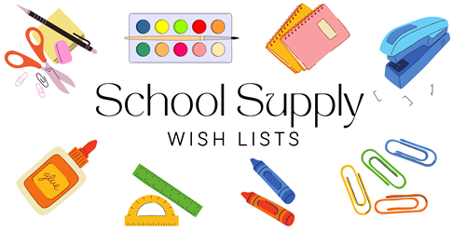

**3rd GRADE**

**24/25**

1 PENCIL POUCH WITH ZIPPER

1 BOX OF CRAYOLA COLORED PENCILS (24ct)

1 BOX OF CRAYOLA MARKERS BROAD TIP

1 BOX OF CRAYOLA CRAYONS (24ct)

6 COMPOSITION NOTEBOOKS – 100ct – ANY COLOR (NOT SPIRAL)

2 FOLDERS WITH PRONGS (1 RED & 1 GREEN)

1 OVER THE HEAD HEADPHONES (NO EARPODS)

8 GLUE STICKS

1 PAIR SCISSORS

30 #2 TICONDEROGA PENCILS (SHARPENED)

4 YELLOW HIGHLIGHTERS

1 PACKAGE OF INDEX CARDS (3x5)

1 RECORDER FOR MUSIC

2 LANYARDS WITH ID HOLDER

3 CLOROX WIPES

2 REAMS COPY PAPER

2 BOXES OF TISSUE

2 MR. CLEAN MAGIC ERASERS

4 BLACK EXPO MARKERS

1 BOX OF QUART SIZE ZIPLOCK BAGS

1 BOX OF GALLON SIZE ZIPLOCK BAGS

1 BOTTLE OF HAND SOAP